**Client Management System**

* **Epic Description**

User Anna wants to manage her client meetings and projects, she needs project management software which will be developed by Henna Solutions, a software company in her town. In addition, Anna needs a web app to manage her clients and client meeting schedules ,address, client id, email ID and password.

* **Developer Name**

Swati Dubey

* **High level Flow of the epic**

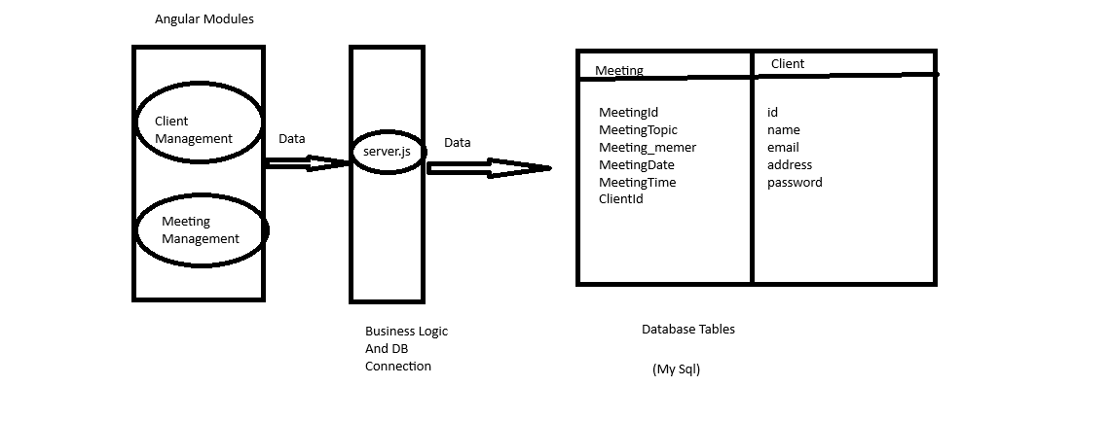**GitHub Link**

https://github.com/swatidubey123/Course1FinalProj.git